**CHAPTER 3**

**MAIN COMPONENTS OF THE SYSTEM**

This chapter describes the main components for robotic arm control system using Arduino Mega 2560. Data sheets and operation of main components in this system are mentioned. According to the material required, the research is designed and constructed easily.

**3.1. Arduino Mega 2560**

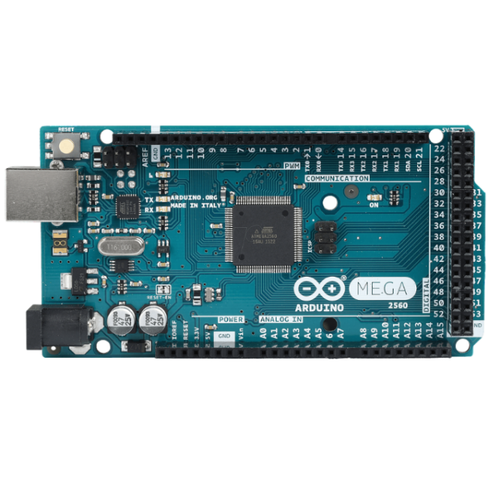The Arduino Mega2560 is a microcontroller board based on the ATmega2560. It has 54 digital input/output pins of which 14 can be used as PWM outputs, 16 analog inputs, a 16 MHz crystal oscillator, a USB connection, a power jack, an ICSP header, and a reset button. It contains everything needed to support the microcontroller; simply connect it to a computer with a USB cable or power it with a AC-to-DC adapter or battery to get started. Features of ATmega2560 Arduino Mega Microcontroller is shown in Table 3.1. The board can operate on an external supply of 6 to 20V. If supplied voltage is less than 7V, the 5V pin may supply less than 5V and the board may be unstable. If using more than 12V, the voltage regulator may overheat and damage the board. The recommended range is 7 to 12V. The Mega2560 differs from all preceding board in that it does not use the FDTI USB-to-serial driver chip. Instead, it features the Atmega8U2 programmed as a USB-to-serial converter. The ATmega2560 has a 256KB of flash memory for storing code, 8KB of SRAM and 4KB of EEPROM. Figure 3.1 shows the Arduino Mega2560.

Figure 3.1. Arduino Mega 2560

Figure 3.2 shows the ATmega2560 pin configuration diagram ATmega2560P is high performance, low power controller from microchip. Features of ATmega2560 Arduino mega microcontroller are shown in Table 3.1.

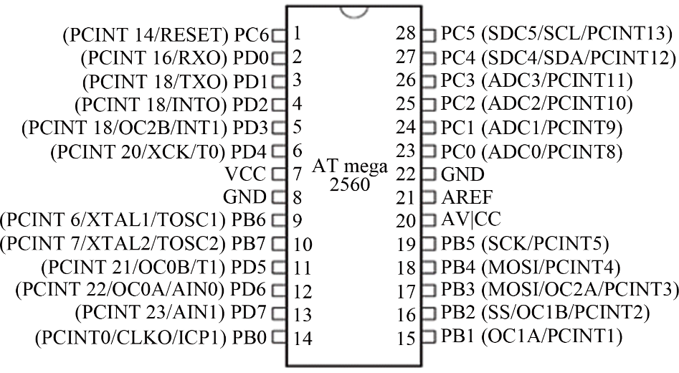

Figure 3.2. Pin Configuration Diagram of ATmega2560

The operating voltage of Mega2560 is 5V. The recommended input voltage is 7V-12V. The number of total digital input and output pins are 54. The number of analog input pins are 16. The flash memory of Mega2560 is 256 kB.

Table 3.1. Features of ATmega2560 Arduino Mega Microcontroller

|  |  |
| --- | --- |
| Key Features | ATmega2560 |
| Operating voltage | 5V |
| Input voltage (Recommended) | 7 to 12V |
| Input voltage (Limits) | 6 to 20 V |
| Digital Input/output pins | 54 (of which 14 provide PWM output) |
| Analog Input Pins | 16 |
| DC Current per I/O Pin | 40mA |
| DC Current for 3.3V Pin | 50 mA |
| Flash Memory | 256 KB of which 8 KB used by boot loader |
| SRAM | 8 KB |
| EEPROM | 4 KB |
| Clock Speed | 16 MHz |
| Operational range | Industrial (-40 o C to 85oC) |

If the RSTDISBL fuse is un-programmed, PC6 is used as a reset input. A low level on this pin for longer than the minimum pulse length will generate a Reset, even if the clock is not running. Shorter pulses are not guaranteed to generate a Reset. Port D (PD7:0) - Port D is an 8-bit bi-directional I/ O port with internal pull-up resistor

(selected for each bit). The Port D output buffers have symmetrical drive characteristics with both high sink and source capability. As inputs, Port D pins that are externally pulled low will source current if the pull-up resistors are activated. The Port D pins are tri-stated when a reset condition becomes active, even if the clock is not running.

VCC is the supply voltage pin for the A/D Converter, PC3:0, and ADC7:6. It should be externally connected to VCC, even if the ADC is not used. If the ADC is used, it should be connected to VCC through a low-pass filter. Note that PC6:4 use digital supply voltage, VCC. AREF is the analog reference pin for the A/D converter. ADC7:6 TQFP and QFN/MLF Package only. In the TQFP and QFN/MLF package, ADC7:6 serve as analog inputs to the A/D converter. These pins are powered from the analog supply and serve as 10-bit ADC channels.

**3.2. HC Serial Bluetooth Module**

The HC serial Bluetooth module is a series of Bluetooth modules used for wireless communication between devices. It typically consists of Bluetooth serial interface module and a breakout board which is also called Bluetooth adapter. The Bluetooth serial interface module such as the HC-05 or HC-06 manages the wireless communication protocols and serial data transmission. The breakout board provides essential features like voltage regulation and pin headers enabling easy integration with microcontrollers like Arduino.

3.2.1. Bluetooth Serial Interface Module

Industrial level is HC-03, HC-04(HC-04-M, HC-04-S). And Civil level is HC

-05, HC-06 (HC-O6-M, HC-06-S), HC-05-D, HC-06-D (with baseboard, for test and evaluation).

Bluetooth serial module is used for converting serial port to Bluetooth. These modules have two modes: master and salve device. The device named after even number is defined to be master or salve when out of factory and can’t be changed to the

other mode. But for the device named after odd number, users can set the work mode (master or slave) of the device by AT commands.

HC-04 specification includes Master device: HC-04-M, M=Master and Slave device: HC-04-S, S=Slaver. The default situation of HC-04 is slave mode. If situation need master mode, it clearly or place an order for HC-04-M directly. The naming rule

When HC-03 and HC-05 ate out of factory, one part of parameters is set for activating the device. The work mode is not set, since user can set the mode of HC-03, HC-05 as they want. The main function of Bluetooth serial module is replacing the serial port line, such as:

There are two MCUs to communication with each other. One connects to Bluetooth master device while the other one connects to salve device. Their connection can be built once the pair is made. This Bluetooth connection is equivalently liked to a serial port line connection including RXD and TXD signals. And they can be the Bluetooth serial module to communication with each other.

When MCU has Bluetooth salve module, it can communicate with Bluetooth adapter of computer or smart phones. Then there is a virtual communicable serial port line between MCU and computer or smart phone.

The Bluetooth devices in the market mostly are salve devices, such as Bluetooth printer, Bluetooth GPS. So, master module can use to make pair and communicate.

Bluetooth serial module’s operation doesn’t need drive, and can communicate with the other Bluetooth devices which have the serial. But communication between two Bluetooth modules requires at least two conditions:

* The communication must be between Mastera salve.
* The password must be corrected.

3.2.2. Selection of the Module

The Bluetooth serial module named even number is compatible with each other. The salve module is also compatible with each other. In other word, the function of HC-04 and HC-06 are former version that user can’t reset the work mode (master or salve). And only a few AT commands and function can be used, like reset the name of Bluetooth (only the salve), reset the password, reset the baud rate and check the version number. The command set of HC-03 and HC-05 are more flexible than HC-04 and HC-06’s. Generally, the Bluetooth of HC-06 is recommended for the user in this system because it only uses for receiving data.

The Bluetooth serial module named even number is compatible with each other.

The salve module is also compatible with each other. In other word, the function of HC-04 and HC-06 are former version that user can’t reset the work mode (master or salve). And only a few AT commands and function can be used, like reset the name of Bluetooth (only the salve), reset the password, reset the baud rate and check the version number. The command set of HC-03 and HC-05 are more flexible than HC-04 and HC-06’s. Generally, the Bluetooth of HC-06 is recommended for the user in this system because it only uses for receiving data. The difference between HC-05 and HC-06 is shown in Table 3.2.

Table 3.2. Difference between HC-05 and HC-06

|  |  |
| --- | --- |
| HC-05 | HC-06 |
| Transmit | - |
| Receive | Receive |
| Master and Slave | Salve |

3.2.3. Bluetooth Module HC-06

This system utilizes Bluetooth module HC-06 to receive wireless signals from Android phone and send it to Arduino. The HC-06 operates on 5V DC and has a default baud rate of 9600 with an effective range of approximately 50 feet. It works as a serial (RX/TX) connection. The Bluetooth module HC-06 is shown in Figure 3.3.

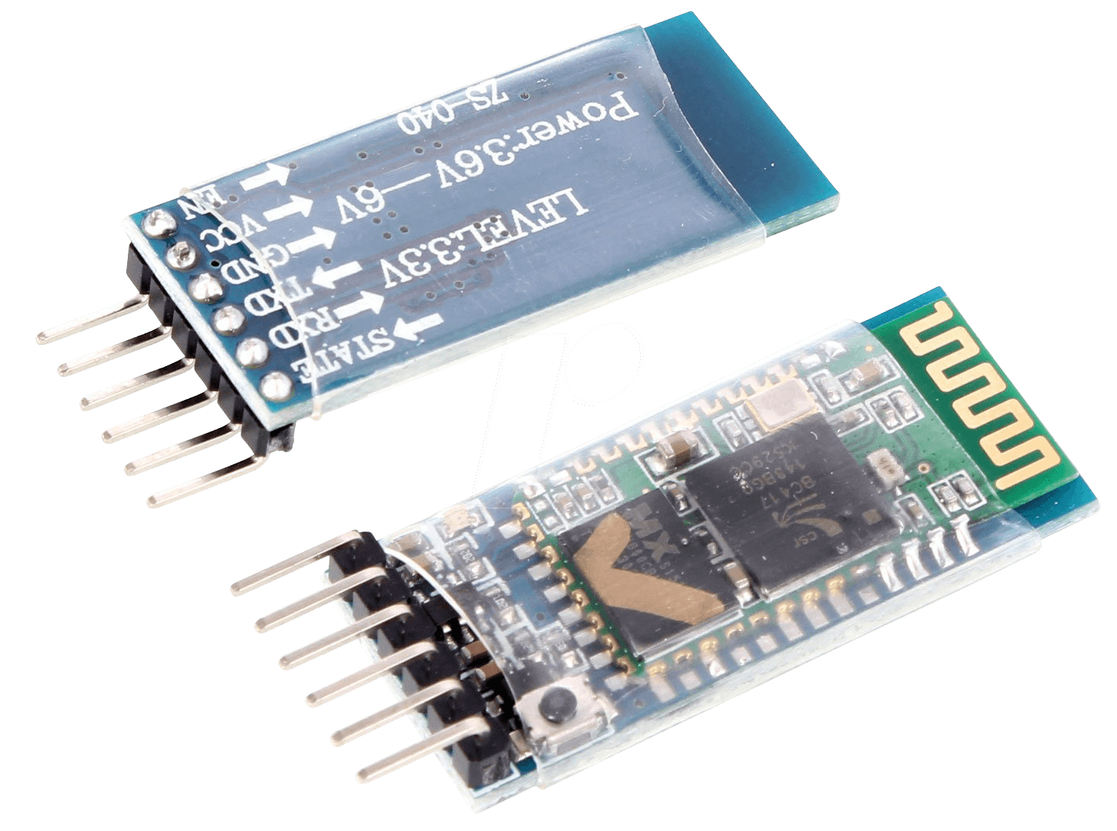

Figure 3.3. Bluetooth Module HC-06

Bluetooth module on the robotic arm is used to receive the commands sent by android device. These are then fed to the motors responsible for controlling the movement of the robotic arm in all directions: front, back, left and right. This Bluetooth module is very handy as it can be easily fitted with a module to allow Bluetooth communication. The HC-06 is a class 2 slave Bluetooth module designed for transparent wireless serial communication. Once it is paired to a master Bluetooth device such as PC, smart phones and tablet, its operation becomes transparent to the user. All data received through the serial input is immediately transmitted over the air. When the module receives wireless data, it is sent out through the serial interface exactly at it is received. The HC-06 operates with a supply voltage ranging from 3.6 VDC to 6 VDC although the logic level of the RXD pin is 3.3V and is not 5V tolerant.

The HC-06 operates in the 2.4GHz ISM frequency band and adopts Bluetooth 2.0+EDR standards. In Bluetooth 2.0, signal transmit time of different devices stands at a 0.5 seconds interval so that the workload of Bluetooth chip can be reduced substantially and more sleeping time can be saved for Bluetooth.

The main parameters of the HC-06 are described as follow; Pairing: On some specific conditions, master and slave device can make each other automatically. Master role: have paired memory to remember last slave device and only make pair with that device unless KEY (PIN26) is triggered by high level. The default connected to PIN26 is low level. Typical method: On some specific conditions, master and slave device can make pair with each other automatically. Multi-device communication: There is only point to point communication for modules, but the adapter can communicate with multi-modules. AT mode: Before paired, it is at the AT mode. After paired it’s at transparent communication. During the communication mode: the module can’t enter to the AT mode. Default communication baud rate: 9600, 1200-1.3M are settable KEY: PIN26, for master abandon memory, LED: The flicker frequency of slave device is 102ms. If master device already has the memory of salve device. The flicker frequency during the pairing is 110ms/s. If not, or master has emptied the memory, then the flicker frequency is 750m/s. After pairing, no matter it’s a master or slave device, the LED PIN is at high level. Notice: The LED PIN connects to LED-PIN. Consumption: During the pairing, the current is fluctuant in the range of 30-40m. The mean current is about 25mA.

After paring, no matter processing communication or not, the current is 8mA. There is no sleep mode. This is no sleep mode. This parameter is same for all Bluetooth modules. Reset: PIN11 is active if it’s input low level. It can be suspended in using.

Features of HC-06 Bluetooth module are wireless transceiver, sensitivity (Bit error rate): can reach -80dBm, the change range of output’s power: up to +4dBm, and

function description (perfect Bluetooth solution), has an EDR module, and the change range of modulation depth: 2Mbps to 3Mbps, has a build-in 2.4GHz antenna and users don’t need to test antenna, has the external 8Mbit FLASH, can work at the low voltage (3.1V-4.2V) and the current in pairing is in the range of 30~40Ma.

Standard HCI Port (UART or USB), USB Protocol: Full speed USB 1.1, compliant with 2.0, this module can be used in the SMD, it’s made through RoHS process, the board PIN is half hole size, Has a 2.4GHz digital wireless transceiver, bases at CSR BC04 Bluetooth technology, Small (27mm*12mm*2mm), peripherals circuit is simple, it’s at the Bluetooth class 2 power level, Storage temperature range: -40 degree Celsius to -80 degree Celsius, Work temperature range: -25degree Celsius to +75degree Celsius, Any wave inters interference: 2.4MHz, the power of emitting: 3dBm, Bit error rate: Only the signal decays at the transmission link, bit error may be produced. For example, when RS232 or TTL is being processed, some signals may decay, Low power consumption, Has high-performance wireless transceivers system and 3Low cost.

Specifications of HC-06 Bluetooth module are Bluetooth protocol: Bluetooth 2.0+EDR standard, USB protocol: USB v1.1/2.0, Operation frequency: 2.4GHz ISM frequency band, Modulation mode: Gauss frequency shift keying, Transmit power: <= 4dBm, second stage, Sensitivity: <= -84dBm at 0.1% bit error rate, Transmission speed: 2.1Mbps (Max)/160k (Asynchronous): 1Mbps/1Mbps (Synchronous), Safety feature: Authentication and encryption, Supported configuration: Bluetooth serial port (major

and minor), Supply Voltage: +3.3VDC 50mA and Size: 36.5*16mm. Application fields of Bluetooth module HC-06 are: Bluetooth Car Hands-free Device. Bluetooth GPS, Bluetooth PCMCIA, USB dongle, Bluetooth data transfer and Software- CS. Pin description of HC-06 is shown in Figure 3.4.



Figure 3.4. Pin Diagram of HC-06 Bluetooth Module

Pin descriptions of HC-06 Bluetooth module are VCC- position pole of the power source, GND**-** Ground, TXD- Serial interface, transmitting terminal, RXD- Serial interface and receiving terminal.

**3.3. DC Gear Motor**

There are many types of gear motor. They are 37mm, 5rpm, 10rpm, low rpm 12V, brush DC micro gear motor, 6mm micro DC gear motor, 42mm 12V 40000rpm gear motor, electronic brushless DC motor, DC electronic motor, DC motor 12V, 24V, 36V, 40V, 48V, 60V power, gear motor for Arduino intelligent car gear motor TT motor robot dc 3V-6V 1:48 etc. This project uses 3V-6V dual shaft DC gear motor.

3.3.1. 3V-6V Dual Shaft Gear Motor

Dual shaft DC geared motor which gives good torque and rpm at lower voltages. This motor can run at approximately 375 rpm when driven by a single Li-ion cell. It is most suitable for light weight robot running on small voltage. Out of two shaft one shaft

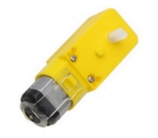can be connected to wheel, other can be connected to the possible encoder. These brushed DC geared motors are compactable and affordable. These make perfect building a quick, miniature robot. They are intended for use at 4.5V, though in general these kinds of motors can run at voltage and below this nominal voltage, so they should operate comfortably in the 3V to 6V range (rotation can start at voltage as low as 0.5V). Geared motor offers the best of speed and current-draw for your particular application. Geared motors are compatible with the wheels. The low current motor is a perfect match for the motor driver. 3V-6V dual shaft DC gear motor is shown in Figure 3.5.

Figure 3.5. 3V-6V Dual Shaft DC Gear Motor

Lower voltage might not be practical, and higher voltage could start negatively affecting the life of the motor. These plastic gearboxes are protected by a built-in safety

that will typically slip before the gear teeth can shear.

3.3.2. Specifications, Features and Applications of 3V-6V Dual Shaft DC Gear Motor

Specifications of DC dual shaft gear motor are strong magnetic DC dual shaft gear motor for toy car, with strong magnetic, anti-interference, suitable for scientific electronic products, robot electric body, bubble gun body, 4WD toy car, toy plane class, class products such as vibration electric toy products, 100% brand new and high quality, color: yellow, reduction ratio: 1:48, working voltage: 3V-6 V, 3V operation, No-load rpm-40, No-load current-50 mA, stall current- 400 mA, stall torque- 44 oz.-in, 6V operation, No-load rpm-78, No-load current- 52 mA, stall current-700 Amp, stall torque -76 0z-in, voltage 3V -Unload current: <=150mA, Unload speed: 90+=10%rpm and Voltage 6V –Unload current: <=200mA, Unload speed: 200+=10%rpm.

Applications of DC dual shaft gear motor are DIY projects, battery-operated toys, disk driver steel rolling mills paper, machines medical equipment, radio-controlled aircraft, automobiles drive systems positioning, Industrial and consumer actuators winches robotics mixers and Robotic projects. Features of DC dual shaft gear motor are shown in Table 3.3.

Table 3.3. Features of DC Dual Shaft Gear Motor

|  |  |
| --- | --- |
| Related voltage | 5.0V |
| Torque | 0.4kg/cm |
| Brush-type | Brush |
| Body size | 70mm * 23mm |
| Shaft size | 8mm * 2mm diameter |
| Weight | 17.5 grams |

**3.4. Motor Driver**

This motor driver is based on the very popular L298 dual H-bridge motor driver integrated circuit. This circuit is allowing too easy and independently controls two motors of up to 2A each in both directions. Figure 3.6 shows L298 Motor driver. It is ideal for robotic applications and well suited for connection to a microcontroller requiring just a couple of control lice per motor. It can also be interfaced with simple

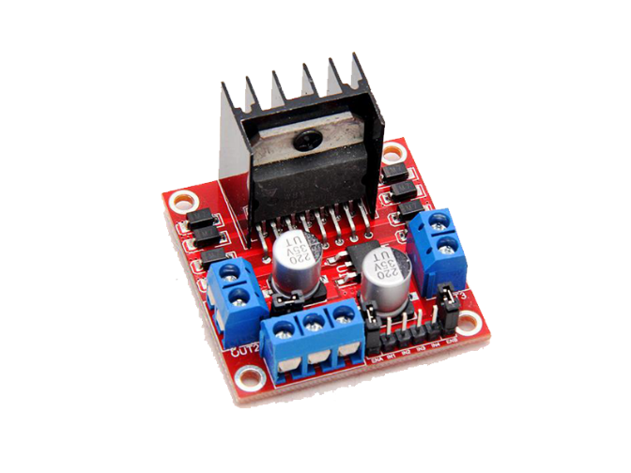manual switches, ITL logic gates, relays, etc. This board equipped with LED indicators, on-board +5V regulator and protection diodes. Figure 3.6 shows L298N motor driver.

Figure 3.6. L298N Motor Driver

This motor driver board is designed for motors which operation voltages are up to 24V. Driver has two channels and delivers 2A current per channel. L298N motor driver IC is used on board. Board can be used at various motor control implementations like line follower robots. Board provides step motor control too.

DC motors controls are harness the kinetic powers of electricity from home. Use controller board to control any device that uses a DC motor, including small robots and cars. Bridge circuit H of featuring AN H-bridge circuit that is able to drive the motors in both directions with this L298N H-bridge circuit. This can also control the speed of the motor and control 2 motors at once.

L298N quality of the L298N driver motor is the best quality. Perfect for home and school projects or for a classroom session. It provides total control motor, produces little heat and is resistant to interference. A stable and reliable motor controller for need.

Low power consumption: Its logical voltage is 5V, driving dc voltage from 5v to 35V while logical current from 0A to 36A and driving current is 2A. This module is based on L298N, high voltage, high current, dual full bridge driver which can be used to drive a DC motor and stepper motor, relay coil inductive load using standard logic level signal control.

L298N motor driver has a 12V battery input which is also used to power an Arduino. The ground wire of L298N motor driver needs to be connected to both the 12V battery (-) and the ground of the Arduino. The Arduino digital pins enable the motors. It provides control of start, stop, back, forward directions and speed to the motor.

Descriptions of L298N motor driver are L298N as main chip, low heat, outstanding anti-interference performance, get power from drive power, however power over 12V, uses the external 5V power as power supply, can drive two dual shaft DC gear motor, high working power to 35V, large current can reach 3A Max and continue current is 2A, power to 25W, large capacity filters capacitance after flow protection diode, more stable and reliable. Pin diagram of L298N motor driver is shown in Figure 3.7.



Figure 3.7. Pin Diagram of L298N Motor Driver

Pinouts of L298N motor driver are OUT 1 and 2: Motor A, OUT 3 and 4: Motor B, +5V: The power supply for external circuit, GND: Ground, +12V: Motor power (can actually be from 5V-35V, just marked as 12V), IN 1: enable motor A, IN 2: enable motor A, IN 3: enable motor B and IN 4: enable motor B. Features of L298N motor driver are shown Table 3.4.

Table 3.4. Features of L298N Motor Driver

|  |  |
| --- | --- |
| Driver chip | L298N H-bridge driver chip |
| Logic voltage | 5V |
| Drive voltage | 5V-35V |
| Logic current | 0mA-36mA |
| Drive current | 2A |
| Storage temperature | -2 to +135 |
| Max power | 25W |
| Weight | 25g |
| Size | 43*43*27mm |
| Compatible | with L297/298 driver |

Specifications of L298 motor driver are input 6V-12V, can control motor speed, can control two motors, each motor takes two data pins to control, to control speed use only PWM pins, need external supply since Arduino can’t give enough amps and ensure that grounds of both Arduino and motor driver are connected.

**3.5. MG996R Servo Motor**

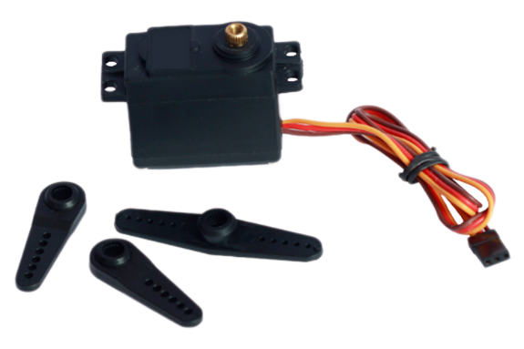 Servo motors are basically geared down dc motors with positional feedback control, allowing for accurate positioning of the motor, with a range of 90 degrees. They can also be modified to allow for continuous rotation. The servo is controlled by three wires: ground (black), power (red) and command (typically white). Power is usually between 4v and 6v and should be separate from system power (as servos are electrically noisy). Servos may be driven to higher voltages to improve torque and aped characteristics. The servo motor has some control circuits and a potentiometer (a variable resistor) that is connected to the output shaft. The pot can be seen on the right side of the circuit board. Figure 3.8 shows servo motor.

Figure 3.8. Servo Motor

This pot allows the control circuitry to monitor the current angle of the servo motor. If the shaft is at the correct angle, then the motor shuts off. If the circuit finds that the angle is not correct, it will turn the motor the correct direction until the angle is correct.

Once the servo has received the desired position (via the PWM signal) the servo must attempt to match the desired and actual position. It does by turning a small, geared

motor left or right. If, for example, the desired position is less than the actual position, the servo will turn to the left. On the other hand, if the desired position is greater than the actual position, the servo will turn to the right. In this manner, the servo “zeros-in’’ on the correct position should a load force the servo horn to the right or left and the servo will attempt to compensate. Servos are commanded through ‘’Pulse Width Modulation,’’ or PWM, signal sent through the command wire. This control signal is a variable-width pulse, which can be varied from 1 to 2ms. The pulse width controls the rotor position. A 1.0 ms pulse rotates the shaft all the way counter-clockwise. A 1.5 ms pulse puts the rotor at neutral (0 degrees), and a 2.0 ms pulse will position the shaft all the way clockwise. The pulse is sent to the servo at a frequency of approximately 50 Hz. Servo motor is used in robotics to activate movements, giving the arm to its precise angle. The servo motor is used to start, move and stop conveyor belts, carrying for instant product labeling, bottling and packaging.

**3.6. CA 2596 Step Down (DC-DC) Converter**

This module features the adjustable CA 2596 step-down (buck) switching regulator, capable of driving a 3A load with excellent line and load regulation. This is an CA 2596 DC-DC buck converter step-down power module with high-precision potentiometer, capable of driving a load up to 3A with high efficiency which can work with Arduino Mega, other mainboards and basic modules. When the output current keeps greater than 2.5A (or output power greater than 10W), please add a heat sink on it.

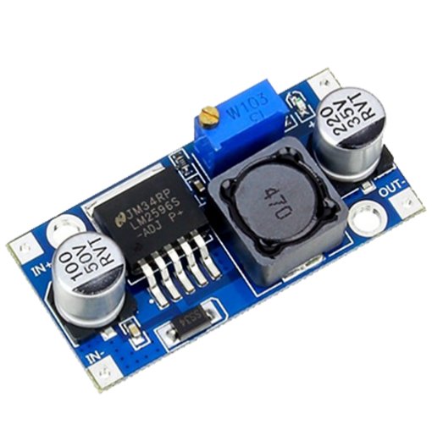 CA 2596 series of regulators are monolithic integrated circuits that provide all the active functions for a step-down(buck) switching regulator, capable of driving a 3A load with excellent line and load regulation. These devices are available in fixed output voltages of 3.3V, 5V, 12V and an adjustable output version. Application includes Simple High-Efficiency Step-Down (Buck) Regulator, On-Car Switching Regulators, Positive to Negative Converter. Figure 3.9 shows the CA 2596 step down (DC-DC) converter.

Figure 3.9. CA 2596 Step Down (DC-DC) Converter

**3.7. Arduino IDE**

For design automated robotics arm system, to have some knowledge in different types of programming languages is needed. By languages people can easily build a connection between Arduino and RFID module and also can store and retrieve data in memory. To receive data from the RFID and send it to the computer and LCD, Arduino and RFID card had been programmed by the Arduino IDE software.

It is known that Arduino IDE is open-source software. It is used to compile the program into the microcontroller. C- Programming language is used for coding in this software. There is two parts in this code mainly. Void setup () is known as preparation for the program and it runs only once, void loop () is known as execution for the program. Figure 3.10 shows the Arduino IDE software.

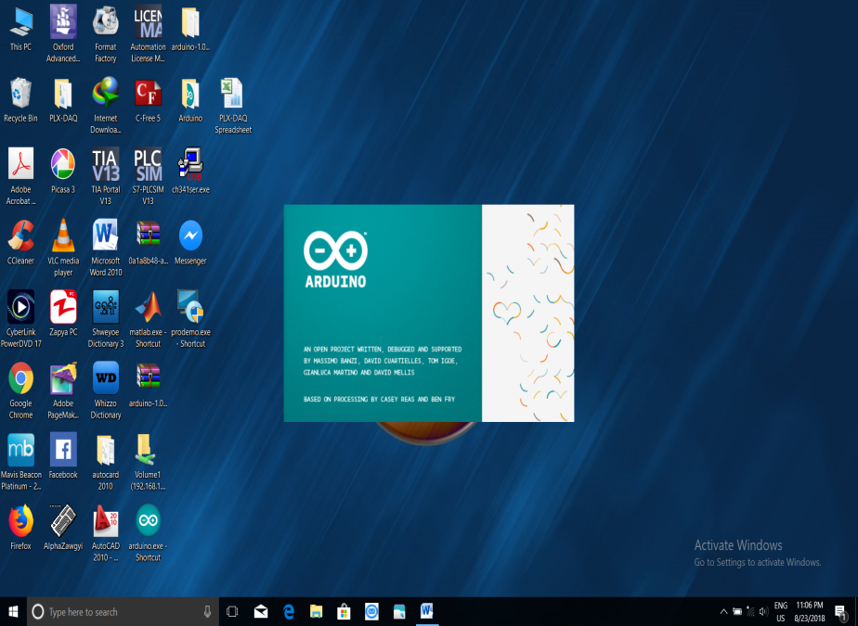

Figure 3.10. Arduino IDE Software

In the button bar, the items are used in the following. The check mark is used to verify code. The arrow uploads code to the Arduino to run. The dotted paper will create a new file. The upward arrow is used to open an existing Arduino project. The downward arrow is used to save the current file. The far right button is a serial monitor, which is useful for sending data from the Arduino to PC. Button bar of Arduino IDE is shown in Figure 3.11.



Figure 3.11. Button Bar of Arduino IDE

**3.8. Summary**

This chapter has been discussed about components of Arduino based robotic arm control system. The above components are very important things for this project. So, this chapter has been discussed detail about components. The next chapter will be mentioned the software implementation and hardware operation of the whole system.